Multiple-choice section

|  |  |  |  |  |  |  |  |  |  |  |
| --- | --- | --- | --- | --- | --- | --- | --- | --- | --- | --- |
| Question | 1 | 2 | 3 | 4 | 5 | 6 | 7 | 8 | 9 | 10 |
| Answer | B | D | C | A | C | D | C | B | D | A |

Question 1 [3.1]

B

18*m*8 ÷ 6*m*2 = 3*m*6

Question 2 [3.6]

D

(*b* – 5)2

= *b*2 – 2 × 5 × *b* + (-5)2

= *b*2 – 10*b* + 25

Question 3 [3.5]

C

-3(2*x* – 1) = -6*x* + 3

Question 4 [3.7]

A

3*p*2 – 15*p* + 27*ap*3 = 3*p*(*p* – 5 + 9*ap*2)

Question 5 [3.3]

C

All non-zero digits are significant.

End zero is not significant.

Middle zeros are significant.

Therefore, there are 5 significant figures.

Question 6 [3.8]

D

*k*2 + 2*k* + 6*k* + 12

= *k*(*k* + 2) + 6*k +* 12

= *k*(*k* + 2) + 6(*k +* 2)

= (*k* + 6)(*k* + 2)

Question 7 [3.1]

C



Question 8 [3.2]

B



Question 9 [3.4]

D



Question 10 [3.2]

A



Multiple-choice total marks: 10

Short answer section

Question 11 3 marks [3.3]

Scientists use scientific notation to write very large or very small numbers in a convenient way. When writing index numbers, the index indicates the number of times that the base is multiplied by itself.

Question 12 2 marks [3.5, 3.7]

‘Factorise’ and ‘expand’ are opposite instructions. To factorise is to express something as a product of its factors (often using brackets). To expand means to multiply these factors (to remove the brackets by multiplying factors inside the brackets by the factors outside).

E.g. 4*x* + 10*xy*:

The common factor is 2*x*, so place it outside of a pair of brackets and place the other factors inside:   
2*x*(2 + 5*y*)

Expanding these brackets gives the original expression:   
2*x* × 2 + 2*x* × 5*y* = 4*x* + 10*xy*

Question 13 6 marks [3.1]

(a) 3*t*2 × 5*t*8 = 15*t*10

**(b)** 12*n*3 ÷ 4*n* = 3*n*2

**(c)**  = 

Question 14 6 marks [3.2]

(a) (3*p*2)4

= 34*p*8

= 81*p*8

(b)



(c) (2*xy*2)3 × (*x*2*y*)5

= 23*x*3*y*6 × *x*10*y*5

= 8*x*13*y*11

Question 15 4 marks [3.2]

(a) 55 × 35

= (5 × 3)5

= 155

(b) *v*-6 = 

(c) *q*7 ÷ *q*11 = *q*-4 = 

Question 16 3 marks [3.2]

(a) 100 = 1

(b) 4*r*0

= 4 × 1

= 4

(c) (13*s*)0

= 130*s*0

= 1 × 1

= 1

Question 17 6 marks [3.2]

(a)



(b)



Question 18 4 marks [3.3]

(a) 92 017 000 = 9.2017 × 107

(b) 3.2 × 104 = 32 000

(c) 5.62 × 10-5

(d) 0.007 23

Question 19 1 mark [3.3]

3.42 × 10-3 × 3.8 × 107 – 8.706 × 10-1

= 129 959

= 1.299 59 × 105

Question 20 3 marks [3.3]

(a) Non-zero significant figures = 5

Zero significant figures = 1

In total, there are 6 significant figures.

(b) Non-zero significant figures = 1

Zero significant figures = 0

In total, there is 1 significant figure.

**(c)** 1.400 × 101

Question 21 2 marks [3.4]

(a)



(b) *km* – *n* = *d*

*km* = *d* + *n*

*km* – *d* = *n*

*n* = *km* – *d*

Question 22 3 marks [3.4]

(a) *A* = × (3 + 4) × 6

*A* = 21 cm2

(b)



Substituting *A* = 21, *h* = 6, *b* = 4:



Question 23 4 marks [3.5]

(a) 5(*x* – 8*z*) = 5*x* – 40*z*

**(b)** -3*p*2(1 – 5*mp*) = -3*p*2 + 15*mp*3

**(c)** 2(*a* + 1) + 4(*a* + *b*)

= 2*a* + 2 + 4*a* + 4*b*

= 6*a* + 4*b* + 2

Question 24 4 marks [3.5]

(a) (*q* + 7)(*q* + 2)

= *q*2 + 2*q* + 7*q* + 14

= *q*2 + 9*q* + 14

**(b)** 2(11 – *a*)(*a* + 3)

= 2(11*a* + 33 – *a*2 – 3*a*)

= 22*a* + 66 – 2*a*2 – 6*a*

= -2*a*2 + 16*a +* 66

Question 25 3 marks [3.5]

(a) *A* = 16 × 18

*A* = 288 m2

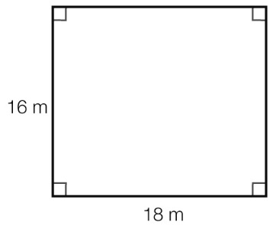

(b) *A* = (16 + *d*) (18 + *d*)  
 = 288 + 16*d* + 18*d* + *d*2  
 = *d*2 + 34*d* + 288

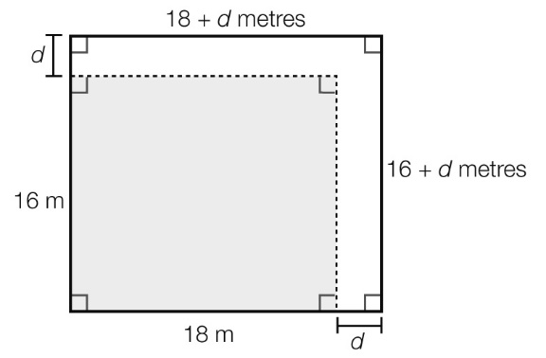

Question 26 4 marks [3.6]

(a) (9 – *z*)2

= 92 – 2 × 9 × *z* + *z*2

= *z*2 – 18*z* + 81

**(b)** (3*n* + 4)2

= (3*n*)2 + 2 × 3*n* × 4 + 42

= 9*n*2 + 24*n* + 16

Question 27 4 marks [3.6]

(a) (*c* – *d*)(*c* + *d*) = *c*2 – *d*2

**(b)** (2*w* + 3*q*)(2*w* – 3*q*)

= (2*w*)2 – (3*q*)2

= 4*w*2 – 9*q*2

Question 28 3 marks [3.7]

(a) 12*x* – 4 = 4(3*x* – 1)

**(b)** 9*Lmn* – 5*mn* = *mn*(9*L* – *5*)

**(c)** 7*g*2*h* – 14*gh*2 = 7*gh*(*g* – 2*h*)

Question 29 4 marks [3.7]

(a) 4*k*2 + 12*k* – 22 = 2(2*k*2 + 6*k* – 11)

**(b)** *t*4 + 6*t*2 – 4*t*3

= *t*2(*t*2 + 6 – 4*t*)

= *t*2(*t*2 – 4*t* + 6)

Question 30 4 marks [3.7]

(a) 3(*a* – 1) + *b*(*a* – 1) = (*a* – 1)(3 + *b*)

(b) 2*p*(3*w* + 2) – 3(3*w* + 2) = (3*w* + 2)(2*p* – 3)

Question 31 2 marks [3.8]

5*x* + 15 – 2*xy* – 6*y*

= 5(*x* + 3) – 2*y*(*x* + 3)

= (*x* + 3)(5 – 2*y*)

Short answer total marks: 75

Extended answer section

Question 32 5 marks [3.3]

(a) 57 910 000 km = 5.791 × 107 km

(b) Zeros between non-zero digits are significant.

Zeros after a non-zero digit are not significant.

There are 4 significant figures.

(c) (1.433 × 109) – (2.2794 × 108) km = 1.20506 × 109 km

Mars is 1.20506 × 109 km closer to the Sun than Saturn.

(d) 149 600 000 km = 1.496 × 108 km

Question 33 6 marks [3.4, 3.5]

(a) 120 = 2*x* + 2*y*

or 120 = 2(*x* + *y*)

(b) 2*x* + 2*y* = 120

2*y* = 120 – 2*x*

*y* = 

= 60 – *x*

(c) *A* = *x* × *y*

*A* = *x*(60 – *x*)

(d) *A* = 60*x* – *x*2

(e) *A* = 60 × 25 – 252

*A* = 875 cm2

*y* = 60 – 25

*y* = 35 cm

Extended answer total marks: 11

TOTAL test marks: 96